Docker and Docker

Commands used:-

**Docker CE Install and start**

sudo amazon-linux-extras install docker

sudo service docker start

sudo usermod -a -G docker ec2-user

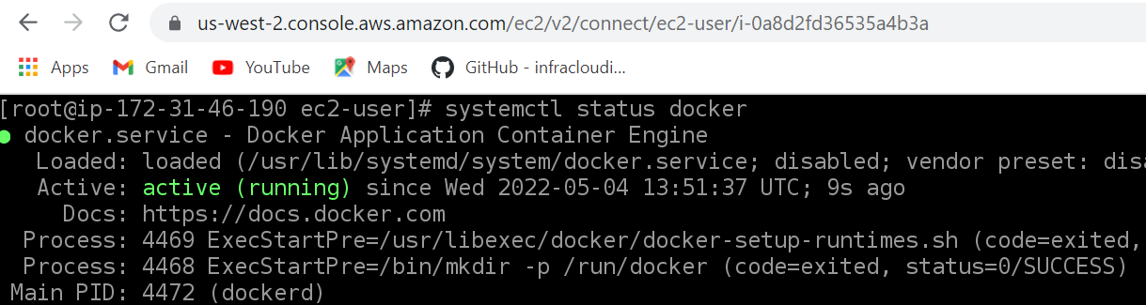

## docker-compose install

Copy the appropriate docker-compose binary from GitHub:

sudo curl -L https://github.com/docker/compose/releases/download/1.22.0/docker-compose-$(uname -s)-$(uname -m) -o /usr/local/bin/docker-compose

sudo curl -L https://github.com/docker/compose/releases/latest/download/docker-compose-$(uname -s)-$(uname -m) -o /usr/local/bin/docker-compose

Fix permissions after download:

sudo chmod +x /usr/local/bin/docker-compose

Verify success:

docker-compose version

**Part 1**

1. Run the container image infracloudio/csvserver:latest in background and check if it's running.

Command: docker run -itd infracloudio/csvserver:latest

1. If it's failing then try to find the reason, once you find the reason, move to the next step.



Write a bash script gencsv.sh to generate a file named inputFile whose content looks like

#!/bin/bash

RANDOM=$$

num=0

ARG1=${1:-10}

while [[ ${num} -le ${ARG1} ]]

do

echo $num $RANDOM

(( num = num + 1 ))

Done

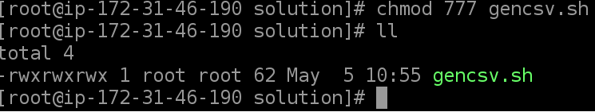

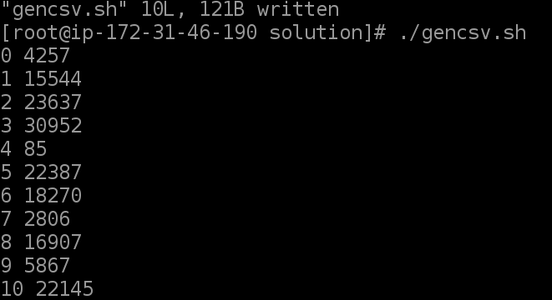

Run script to generate inputFile by command: ./gencsv.sh > inputFile

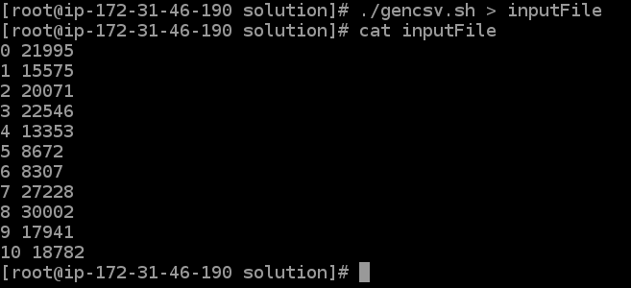

1. Run the container again in the background with file generated in (3) available inside the container (remember the reason you found in (2)).

Copy inputFile to container

docker cp . agitated_villani:/csvserver/



login into container to see ifinputFile is present by command

docker exec -it agitated_villani /bin/bash



1. Get shell access to the container and find the port on which the application is listening. Once done, stop / delete the running container.



* The application is accessible on the host at [http://localhost:9393](http://localhost:9393/)

docker exec -it condescending_ride ./csvserver

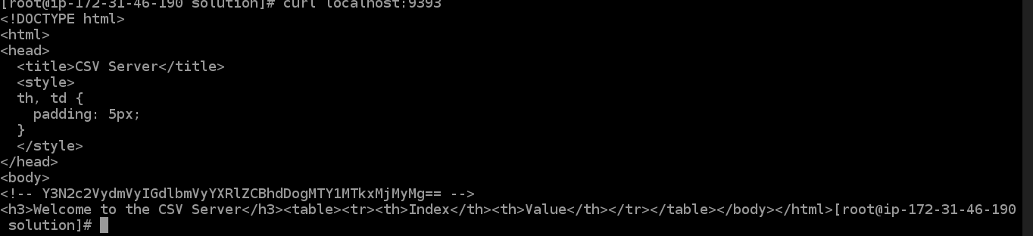

Full Command: docker run -d -p 9393:9300 --env CSVSERVER_BORDER=Orange --volume=$(pwd)/inputFile:/csvserver/inputdata infracloudio/csvserver

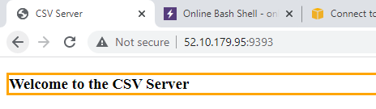

docker-compose.yml

version: '2.5'

services:

web:

image: infracloudio/csvserver

volumes:

- /root/csvserver/solution/inputFile:/csvserver/inputdata

ports:

- "9393:9300"

environment:

- CSVSERVER_BORDER=Orange

prometheus:

image: prom/prometheus:v2.22.0

ports:

- "9090:9090"

volumes:

- /root/csvserver/solution/inputFile:/data

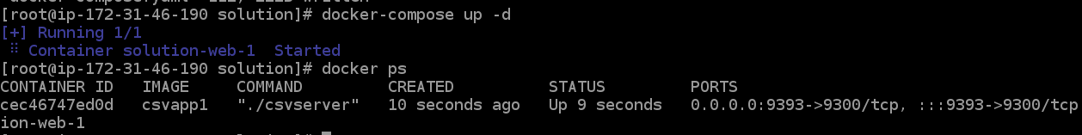

Prometheus accessible on localhost:9090

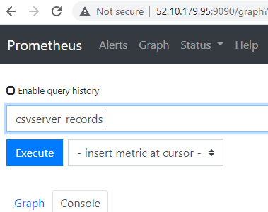

docker run -it -p 9090:9090 prom/prometheus:v2.22.0